**Solution Approach Document**

Solution Approach Document: **Employee CRUD**

|  |  |  |  |
| --- | --- | --- | --- |
| Version: | 1.0 | Version Release Date: | 12/07/2021 |
| Author(s): | Khalid Qassem | Document Status: | **FINAL** |

Contents

1 Introduction 3

1.1 Purpose 3

1.2 Reference documents 3

1.3 Assumptions 3

1.4 Architectural Decisions 3

2 Solution APPROACH 4

2.1 System Architecture Overview 4

2.2 API Interface Document 4

2.3 Data Model 5

2.4 How to use 6

2.5 Repo link 7

# Introduction

## Purpose

The purpose of this document is to define the solution approach for a sample application contains create, read, update and delete operations for an Employee Object, using Java rest backend (Spring) and swagger-ui as a client.

## Reference documents

|  |  |  |  |  |
| --- | --- | --- | --- | --- |
| ID | Name | Version | Author | Location and Attachment |
| 1 | Requirements Specification Document | V1.0 |  |  |
| 2 | Github code branch |  | Khalid | <https://github.com/khaledkasm/Sample-Project-Assignment-Solution-Architect.git> |

## Assumptions

|  |  |  |
| --- | --- | --- |
| ID | Details | Approved by |
| 1 | Employee salary has to be 1 or more |  |
| 2 | While creating the employee, we assume the department already created and the manager already created. |  |

## Architectural Decisions

|  |  |  |  |
| --- | --- | --- | --- |
| ID | Issue | Reasoning & Decision | Approved by |
|  |  |  |  |

# Solution APPROACH

## System Architecture Overview



## API Interface Document

You can use swagger documentation from the below link

<http://localhost:8080/swagger-ui/index.html?configUrl=/v3/api-docs/swagger-config#/>

## Data Model

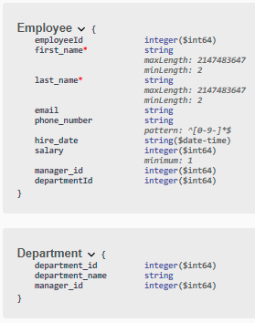

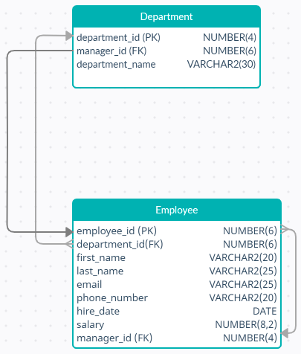

## How to use

1. Run the application then go to the link <http://localhost:8080/swagger-ui/index.html?configUrl=/v3/api-docs/swagger-config#/>
2. Create an employee with the following request

{

"first_name": "Khalid",

"last_name": "Qassem",

"email": "khaledkasm@gmail.com",

"phone_number": "9435-4841",

"hire_date": "2021-12-07T11:25:22.703Z",

"salary": 1000,

"manager_id": null,

"departmentId": null

}

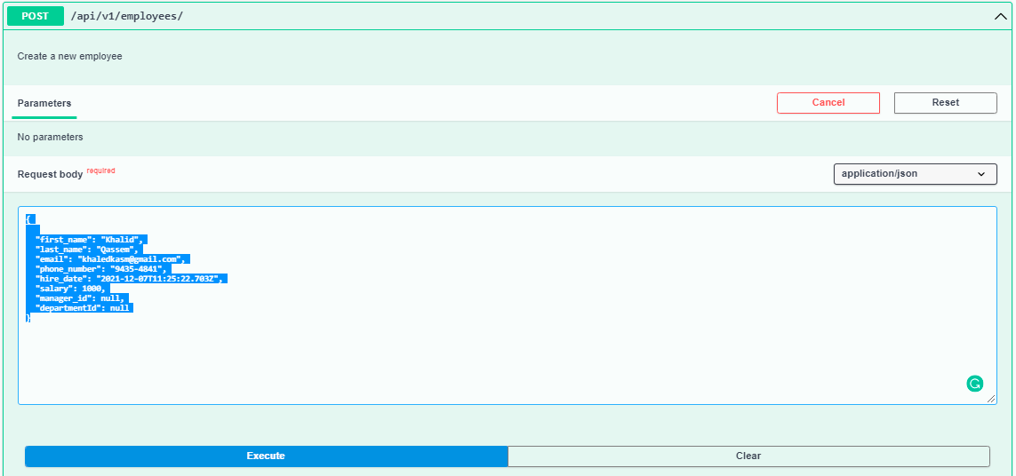

1. You can retrieve the employee by executing the following request

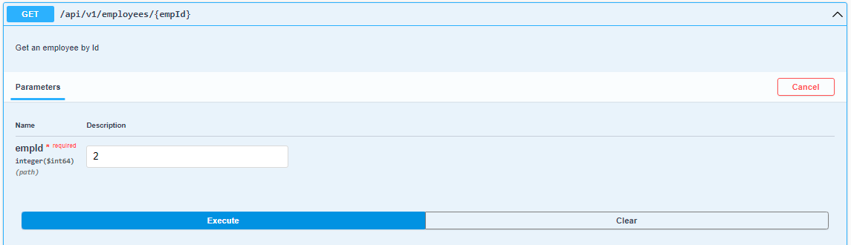

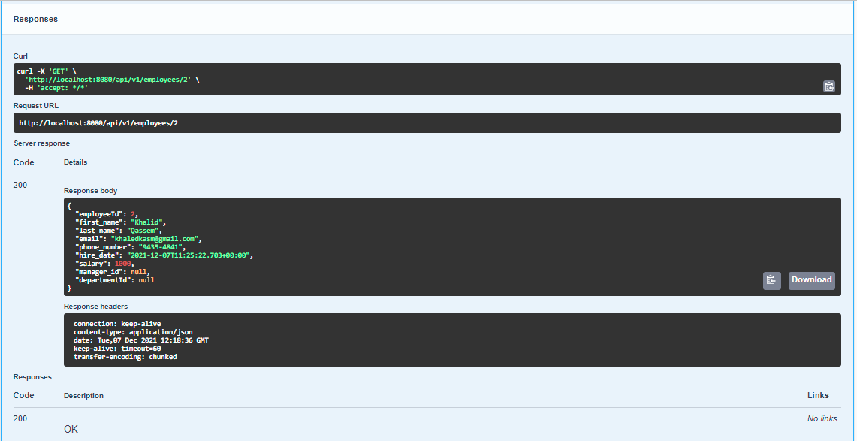

## Repo link

<https://github.com/khaledkasm/Sample-Project-Assignment-Solution-Architect.git>